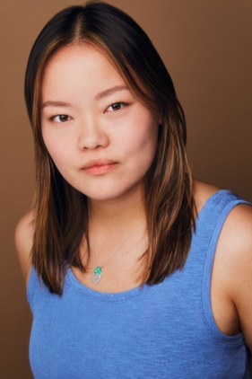**Anna Gullion**

JTA Talent Agency annagullion@gmail.com

820 East Blvd, Charlotte,

NC 28203 [(704) 377-5987](https://www.google.com/search?q=jta+talent+agency&oq=jta+&aqs=chrome.1.69i57j69i59j46i39i175i199j46i131i433i512j0i3j0i3i10j0i131i433j69i61.2473j0j7&sourceid=chrome&ie=UTF-8)

Height: 5’5’’ Age Range: 16-22 Weight: 155 lbs.

**FILM/TV**

|  |  |  |
| --- | --- | --- |
| *Translating Livia Ming*  *POP!*  *Sisters*  *A Tender Moment* | Supporting  Lead  Lead  Lead | Patrick Wei  Becca Potters  Keith Harris  Elon University |

**COMMERCIAL**

|  |  |  |
| --- | --- | --- |
| *Red Hat* | Principle | Dash Studios |

**THEATRE**

|  |  |  |
| --- | --- | --- |
| *The Inferior Sex*  *The Cherry Orchard*  *The Elephant Man* | Joan  Varya  Bishop How/Conductor | Elon University (Sarah Hankins)  Elon University (Kevin Otos)  Elon University |
| *Hamlet* | Gertrude U/S | Elon University (Kevin Otos) |
| *#Silenced* | Actor 10 | Elon University |

**TRAINING**

|  |  |  |  |
| --- | --- | --- | --- |
| *Bachelor of Fine Arts Acting* 2023  Elon University – Elon, NC  *On-Camera Technique*  in-Studio – Greensboro, NC | |  | |
| *Acting* | | Kevin Otos Kirby Wahl, Kevin Hoffman, Drew Mathews, Kelsi Chandler, Donald Elise Watkins, Lee Spencer (Camera technique), Madeleine Potter | |
| *Dance* | | Denise Stone | |
| *Voice*  *Stage Combat* | | Miriam Nelson, Alicia Reed  R.C. Annie | |
| *Theatrical Intimacy* | | Kim Shively | |

**SPECIAL SKILLS**

Dance — ballet, tap, jazz, contemporary, hip-hop, Guitar — electric and acoustic, Voice — mezzo-soprano, Cartwheel (both sides and one handed), Splits (both leg), Cooking, Baking, Volleyball, Visual Art — pencil, pen and ink, acrylic, oil pastel, soft pastel, watercolor, BADC Certified - Rapier and Dagger, Accents — British RP, London, Irish (more upon request) valid passport, licensed driver